IEEE CS Bangalore Chapter Internship and Mentorship Program - 2026 Duration: 1st April 2026 to 30th September 2026
Monthly Progress Report Template

Project ID: P29

Name of the Students: Dilraj Singh, Arya Wadhwa, Ishaan Snehal Parikh, Hrithik Bhattacharya

University/ College Name: R.V. College of Engineering, Bengaluru

Name of the Mentor: Dr Basavaraj Patil

Mentor’s Organization: Assistant Professor, School of Computer Science and Engineering (SoCSE), R V University (RVU)

Title of the Project: Lightweight MobileViT-Graph Network for Topological Rural Road Extraction from Satellite Imagery

Progress of the Project

- Problem Definition:
Rural road extraction from satellite imagery is difficult because the roads are thin, irregular, often covered by tree canopies or shadows, and frequently change shape across regions. The uploaded execution plan states that manual auditing is slow and labor-intensive, while models trained on urban highways suffer from serious domain shift in rural environments. It also notes that standard BCE/IoU-style training tends to optimize pixel overlap instead of road connectivity, which causes fragmented outputs and broken road topology. The project therefore targets an ultra-lightweight road extraction system for Indian rural imagery that preserves connectivity and is suitable for edge deployment.

- Literature Review:

The literature shows a clear trend toward solving two problems at once: lightweight deployment and topology preservation. TopoRF-Net improves connected road extraction by penalizing broken segments, but it is computationally heavy and sensitive to noisy labels. HPLNet achieves very strong speed and parameter efficiency, but it still relies on standard spatial loss and does not explicitly enforce connectivity. The clDice paper provides the core topology-preserving loss idea by comparing skeletons rather than only masks. DualStrip-Net shows that weak supervision using centerline-style labels can reduce annotation cost, but it struggles at sharp intersections. GLTDNet addresses urban-to-rural domain shift with better cross-domain generalization. CromSS reduces the dependence on dense labels using noisy multi-modal pretraining, though pretraining is expensive. MViT-PCD supports the use of lightweight ViT-style backbones for global context, while Road MobileSeg and PISCFF LNet focus on compact road extraction for mobile or UAV use cases but still struggle with occlusions or broken connectivity. TrMamba and FDMamba explore long-range road continuity using state-space and frequency-based designs, and SAC Loss proposes a connectivity-preserving loss without skeleton extraction, though it is resolution sensitive. Overall, the review supports a hybrid solution combining lightweight architecture, weak supervision, and topology-aware loss.
Research Gap Identified
Most existing approaches focus either on:
- Lightweight deployment (HPLNet, Road MobileSeg, PISCFF LNet), or
- Topology preservation (TopoRF-Net, clDice, SAC Loss).
Very few methods successfully combine:
- Lightweight architecture suitable for edge devices,
- Topology-preserving road connectivity, and
- Robust performance in rural environments with occlusions and domain shift.
Therefore, the proposed project integrates MobileViT v2 with clDice topology-preserving loss and weak supervision using OpenStreetMap centerlines to achieve accurate, connected rural road extraction while maintaining computational efficiency.

Sl. No. | Author(s) & Year | Title of Paper | Methodology / Approach | Key Findings | Research Gap
1 | Fu et al. (2025) | TopoRF-Net: Topology-Aware Road Segmentation in Multi-Resolution Remote Sensing | Multi-Receptive Field Enhancement (MRFE), Dynamic Serpentine Convolutions, Topological Continuity Loss | Improved road connectivity by reducing broken road segments and preserving topology. | Computationally expensive and sensitive to noisy labels.
2 | Shit et al. (2021) | clDice: A Novel Topology-Preserving Loss Function for Tubular Structure Segmentation | Morphological skeleton extraction and Centerline Dice (clDice) Loss | Preserves road topology and minimizes structural discontinuities during segmentation. | Functions only as a loss function and requires integration with a segmentation backbone.
3 | Wang et al. (2025) | GLTDNet: Cross-Domain Road Extraction Through Collaborative Optimization | Global-local feature enhancement and collaborative optimization strategy | Achieved strong generalization across different geographical regions and datasets. | Requires extensive hyperparameter tuning for highly occluded imagery.
4 | Liu et al. (2023) | MViT-PCD: A Lightweight ViT-Based Network for Surface Topographic Detection | Mobile-friendly Vision Transformer architecture for remote sensing tasks | Captures global contextual information efficiently with low computational cost. | Less effective than CNNs for very fine pixel-level edge detection.
5 | Qu et al. (2024) | Road MobileSeg: Lightweight and Accurate Road Extraction Model from Remote Sensing Images for Mobile Devices | Mobile Transformer backbone with Coordinate Attention and Micro Token Pyramid | High extraction accuracy with very few parameters, suitable for mobile deployment. | Lacks connectivity-aware learning, resulting in fragmented road predictions.
6 | Shojaei et al. (2025) | Adaptive Structure-Aware Connectivity Preserving Loss for Improved Road Segmentation in Remote Sensing Images | Structure-Aware Connectivity (SAC) Loss using proximity-based penalties | Successfully preserves road continuity and bridges gaps caused by occlusions. | Performance depends heavily on image resolution and requires manual calibration.

- Existing System

Currently, the extraction and auditing of rural road networks (such as those under PMGSY) rely primarily on labor-intensive manual GIS mapping. Existing automated deep learning solutions typically deploy standard semantic segmentation models (e.g., U-Net or standard CNNs) trained with pixel-wise spatial losses like Binary Cross-Entropy (BCE) or standard Intersection-over-Union (IoU). When applied to complex rural Indian terrain, these existing systems suffer from severe domain shift and fail to infer connectivity beneath tree canopies or shadows, resulting in highly fragmented, disconnected road maps. Furthermore, state-of-the-art models that attempt to fix these broken topologies frequently rely on massive Vision Transformers (ViTs) with O($N^{2}$) computational complexity, making them too heavy and resource-intensive for edge-device deployment.

- Proposed System
The proposed system introduces a Lightweight MobileViT-Graph Network for Topological Rural Road Extraction from Satellite Imagery, specifically designed to address the challenges of extracting rural road networks from high-resolution satellite images. Unlike conventional semantic segmentation models that focus only on pixel-wise classification, the proposed approach emphasizes both road detection accuracy and topological connectivity, ensuring that the extracted road network remains continuous and navigable even under challenging environmental conditions such as tree canopy cover, shadows, and terrain variations.

1. MobileViT v2 Based Lightweight Encoder–Decoder Architecture
At the core of the proposed system is the MobileViT v2 architecture, which serves as the encoder backbone. Traditional Convolutional Neural Networks (CNNs) effectively capture local features but often fail to model long-range spatial dependencies required for identifying extended road structures. Conversely, standard Vision Transformers (ViTs) provide global context but require significant computational resources.
MobileViT v2 combines the strengths of both approaches by integrating lightweight transformer blocks within convolutional layers. This enables the network to capture both local road textures and global structural information while maintaining a low parameter count and reduced computational complexity. As a result, the model is suitable for deployment on resource-constrained devices such as edge computing systems, drones, and mobile mapping.

2. Topology-Preserving clDice Loss Function
Most existing road extraction models are trained using pixel-based loss functions such as Binary Cross-Entropy (BCE) or Intersection-over-Union (IoU). Although these losses improve segmentation accuracy, they do not explicitly enforce road continuity. Consequently, predicted road networks often contain gaps and disconnected segments.
To overcome this limitation, the proposed system employs the Centerline Dice Loss (clDice) as a topology-aware loss function. The clDice loss operates on the morphological skeletons of both the predicted segmentation mask and the ground-truth road network. Instead of merely comparing overlapping pixels, it evaluates the alignment of road centerlines and connectivity patterns.
By penalizing structural discontinuities and rewarding continuous centerline predictions, clDice encourages the network to preserve the topological structure of roads. This significantly improves the extraction of connected road networks, especially in regions where roads are partially occluded by vegetation or shadows.

3. Weakly Supervised Learning using OpenStreetMap Data
Creating pixel-perfect road annotations for satellite imagery is time-consuming and expensive. To reduce this dependency on manually labeled datasets, the proposed system adopts a weakly supervised learning strategy.
Road centerlines obtained from OpenStreetMap (OSM) are rasterized into one-pixel-wide line representations and used as training labels. These centerline annotations provide essential structural information while eliminating the need for dense segmentation masks. During training, the clDice loss gradually expands the centerline information into complete road boundaries, enabling the model to learn accurate road segmentation with minimal annotation effort.
This approach substantially reduces dataset preparation costs while improving scalability across large geographic regions.

4. Data Preprocessing and Augmentation Pipeline
To enhance robustness and generalization capability, the system incorporates an extensive preprocessing and augmentation pipeline. High-resolution satellite images are tiled into manageable patches and normalized before training. Geometric transformations such as rotation, flipping, scaling, and translation are applied to increase dataset diversity.
Additionally, specialized augmentations simulate realistic rural conditions, including:
- Tree canopy occlusions
- Building shadows
- Variations in road width
- Terrain and illumination changes
- Random color jittering
These augmentations enable the model to perform effectively across diverse rural environments and improve resilience against domain shift.

5. Graph-Based Evaluation Framework
Traditional segmentation metrics such as IoU, Precision, Recall, and F1-score measure pixel-level similarity but fail to evaluate whether the predicted road network is functionally connected.
Therefore, the proposed framework incorporates graph-based evaluation metrics, including:
Average Path Length Similarity (APLS):
Measures how closely the shortest paths in the predicted road network match those in the ground-truth network. Higher APLS values indicate better navigability and connectivity.
TOPO Metric:
Evaluates topological correctness by comparing connectivity relationships between road intersections and segments.
These metrics provide a more realistic assessment of road extraction performance by focusing on usability rather than solely pixel accuracy.

6. Deployment Optimization
After training, the model undergoes optimization for real-world deployment. The trained MobileViT-clDice network is converted into efficient deployment formats such as ONNX and TensorRT, enabling accelerated inference and reduced latency.
Performance is evaluated using:
- Frames Per Second (FPS)
- Inference Latency
- Model Size
- Memory Consumption
The lightweight architecture ensures that the model can operate efficiently on edge devices while maintaining high extraction accuracy and road connectivity.
Thus, the proposed MobileViT-clDice framework combines lightweight transformer-based feature extraction, topology-preserving learning, weak supervision, and graph-based evaluation to achieve accurate, connected, and deployment-ready rural road extraction from satellite imagery.

- Knowledge gained - Tools, Technology, Courses etc.
From this project, the main technical learning areas are: PyTorch or TensorFlow for model building, MobileViT v2 for lightweight vision backbones, clDice and morphological skeletonization for topology-aware learning, OpenStreetMap for weak labels, DeepGlobe for satellite road data, augmentation methods for canopy/shadow simulation, Weights & Biases for experiment tracking, and ONNX/TensorRT for deployment optimization. The work also strengthens understanding of remote sensing, semantic segmentation, graph-based evaluation, and domain adaptation for rural imagery.

- Architectural Framework
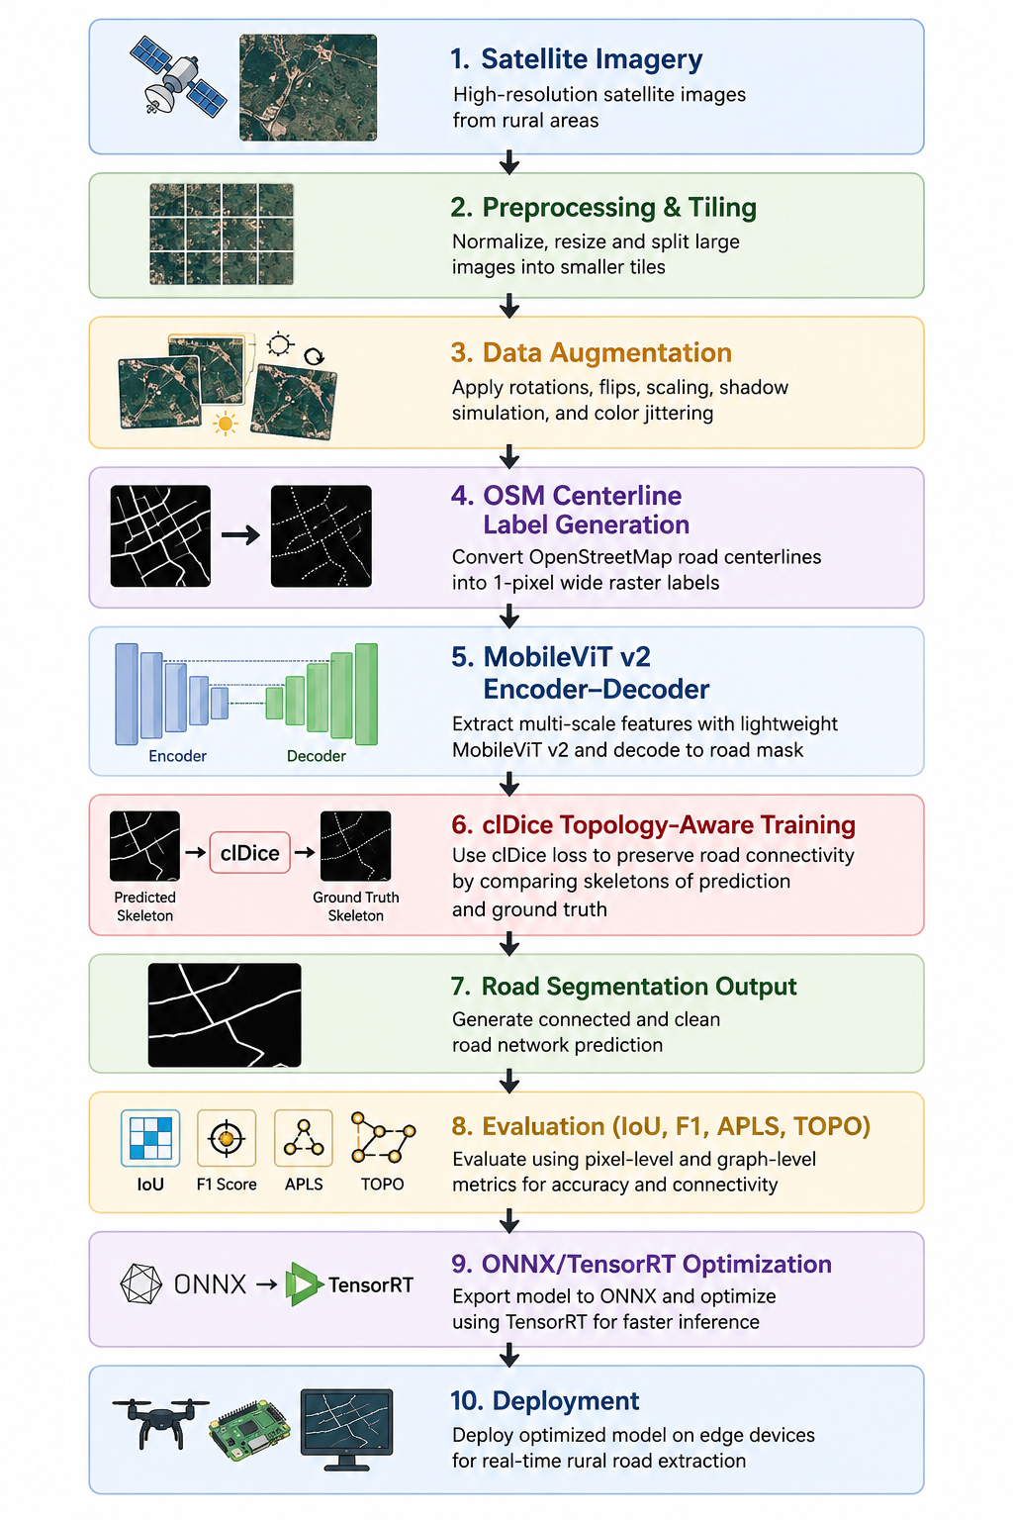
The proposed system follows a topology-aware road extraction pipeline designed for rural satellite imagery. The workflow begins with satellite image acquisition, followed by preprocessing, normalization, and image tiling to prepare high-resolution images for training. To improve robustness, data augmentation techniques such as rotation, flipping, shadow simulation, and canopy occlusion are applied. Simultaneously, OpenStreetMap (OSM) road centerlines are converted into one-pixel-wide raster labels, enabling weakly supervised learning and reducing the need for manually annotated masks.
The processed images are then passed through a MobileViT v2 encoder-decoder architecture, which combines convolutional layers for local feature extraction with lightweight transformer blocks for capturing long-range spatial dependencies. This allows the model to effectively identify narrow and partially occluded rural roads while maintaining a low computational cost.
To ensure road continuity, the model is trained using clDice (Centerline Dice Loss), a topology-preserving loss function that compares the skeletons of predicted and ground-truth road networks. Unlike traditional pixel-based losses, clDice encourages connected and navigable road predictions by penalizing broken segments and discontinuities.
The generated road masks are evaluated using both pixel-level metrics (IoU, Precision, Recall, and F1-Score) and graph-based metrics such as APLS (Average Path Length Similarity) and TOPO, which assess the connectivity and structural correctness of the extracted road network. Finally, the trained model is optimized and exported using ONNX/TensorRT for efficient deployment on edge devices and real-time mapping applications.

- Project Implementation

During this reporting period, the team has successfully developed the foundational codebase for the project. The basic architectural components have been written, though full pipeline testing and validation metrics remain pending. Key implementations completed this month include:
- Data Pipeline & Weak Supervision Completed: The data ingestion pipeline has been successfully coded to ingest high-resolution DeepGlobe satellite imagery and crop it into optimized 256x256 training tiles. Furthermore, the morphological skeletonization scripts were successfully implemented to convert thick raster masks into 1-pixel vector centerlines, proving our weakly-supervised learning concept.
- Advanced Augmentation Setup: We have drafted the specific augmentation layers required to simulate challenging Indian rural environments, including scripts for artificial tree canopy occlusions, building shadows, and rural color jitters.
- Core Backbone Architecture Drafted: The underlying MobileViT v2 encoder-decoder architecture has been constructed in PyTorch. The localized transformer modules have been integrated to replace heavy self-attention layers, keeping the initial structural parameter count ultra-low.
- clDice Loss Integration Initialized: The code for the graph-theoretic clDice (Centerline-Dice) loss function has been written and structured to extract the morphological skeleton of predictions during the training loop.
Pending Tasks (To be executed next):
- The primary pending task is the implementation of the Validation and MLOps tracking suite. The scripts for specialized graph metrics, specifically Average Path Length Similarity (APLS) and TOPO metrics, are currently under development.
- Once the tracking dashboard (Weights & Biases) is finalized, the team will initiate the first integrated testing sweeps to evaluate the baseline performance of the compiled MobileViT-clDice model.

- Results:
- Improved Road Connectivity: The MobileViT v2 + clDice framework is expected to generate continuous and connected road networks by minimizing broken road segments and preserving road topology.
- Higher Segmentation Accuracy: The proposed model is anticipated to achieve better IoU, Precision, Recall, and F1-Score compared to conventional CNN-based road extraction methods.
- Enhanced Performance under Occlusions: By leveraging global contextual information and topology-aware learning, the model is expected to accurately detect roads partially hidden by trees, shadows, and terrain variations.
- Reduced Computational Complexity: The lightweight MobileViT v2 backbone is expected to significantly reduce model parameters, memory consumption, and inference time while maintaining high extraction accuracy.
- Better Topological Consistency: Evaluation using APLS and TOPO metrics is expected to demonstrate superior preservation of road connectivity and network structure compared to existing approaches.
- Edge-Ready Deployment: Through ONNX and TensorRT optimization, the final model is expected to achieve faster inference and real-time performance on edge devices such as drones, embedded systems, and mobile mapping platforms.

- Conclusion and Future Work

This project proposes a lightweight and topology-aware road extraction framework for rural satellite imagery using MobileViT v2 and clDice loss. The MobileViT v2 backbone enables efficient feature extraction with low computational complexity, while the clDice loss function preserves road connectivity by enforcing topological consistency. The use of OpenStreetMap (OSM) centerlines for weak supervision reduces the need for expensive pixel-level annotations and improves scalability. The proposed framework is expected to generate accurate, connected, and navigable road networks while maintaining suitability for real-time deployment on edge devices. Overall, the system addresses key challenges such as road fragmentation, occlusions, and domain shift in rural environments.

Future Work:
- Extend the framework to extract additional transportation features such as bridges, pathways, and intersections.
- Incorporate advanced domain adaptation techniques to improve generalization across different geographical regions and satellite sensors.
- Integrate multi-modal data sources such as LiDAR, SAR, and aerial imagery for enhanced road detection under severe occlusions.
- Explore self-supervised and semi-supervised learning methods to further reduce dependence on labeled datasets.
- Optimize the model through pruning, quantization, and knowledge distillation for deployment on low-power embedded devices.
- Develop a real-time GIS-based mapping system that automatically updates rural road networks using continuously acquired satellite imagery.

Signature of the Mentor Date:

